~Day-2
- List 3 real-world devices in your home or college that use SMPS (Switched Mode Power Supply) and 2 devices that use UPS (Uninterruptible Power Supply), explaining in one line why each device needs that type of power supply.

:-Devices That Use SMPS (Switched Mode Power Supply)
Device | Why it uses SMPS
Desktop Computer | SMPS converts AC power into different DC voltages required by computer components efficiently.
Laptop Charger | SMPS provides stable DC power while being compact and energy-efficient.
LED Television | SMPS supplies regulated power to the TV's internal circuits with low power loss.

:-Devices That Use UPS (Uninterruptible Power Supply)
Device | Why it uses UPS
Desktop Computer | UPS provides backup power during outages, preventing data loss and sudden shutdowns.
Wi-Fi Router | UPS keeps the internet connection running during power cuts for uninterrupted connectivity.
- Draw and label a diagram showing the main internal components of a typical SMPS unit found in a desktop PC, including AC input, rectifier, transformer, and DC output sections.<br><br><em><strong>Hint:</strong> You can hand-draw and upload a photo, or use any free diagram tool like draw.io.</em>
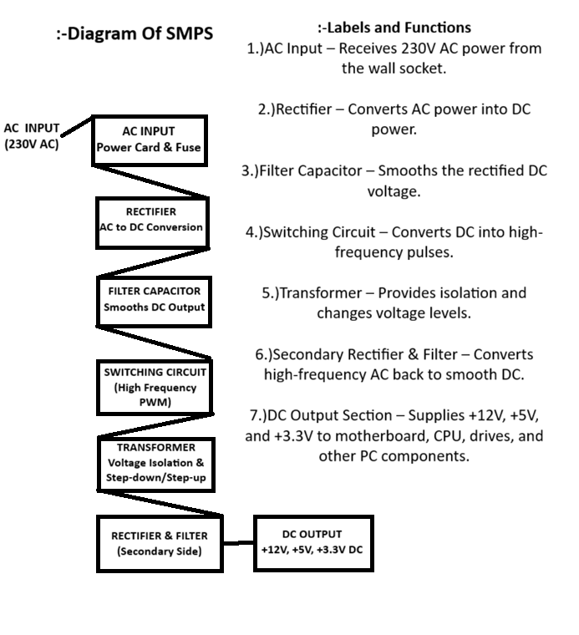
- Take photos or find clear images online of the following power connectors: ATX 24-pin motherboard connector, SATA power connector, Molex connector, and PCIe 6/8-pin connector. For each, write its name, the devices it powers, and one safety tip for connecting/disconnecting it.

1.) ATX 24-Pin Motherboard Connector:-

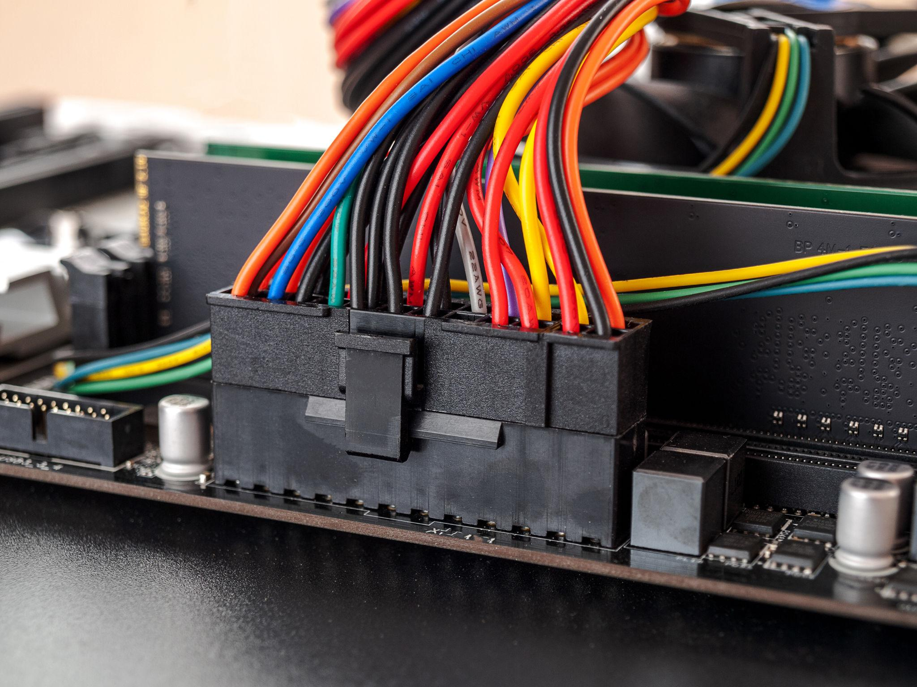
Purpose: Powers the motherboard and distributes power to major system components.
Devices Powered:
- Motherboard
- CPU power circuits
- RAM and onboard components
Safety Tip: Always turn off the PSU and unplug the power cable before connecting or disconnecting the 24-pin connector.
2.) SATA Power Connector
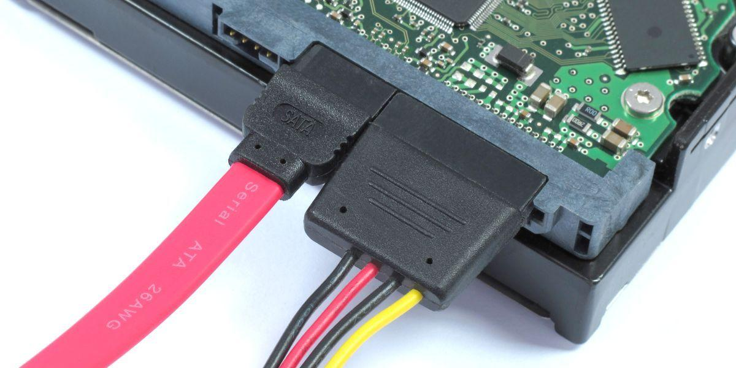
Purpose: Provides power to modern storage devices.
Devices Powered:
- SATA SSDs
- SATA HDDs
- DVD/Blu-ray drives
Safety Tip: Do not force the connector; it is L-shaped and only fits in one direction.
3.)Molex Connector (4-Pin Peripheral Connector)
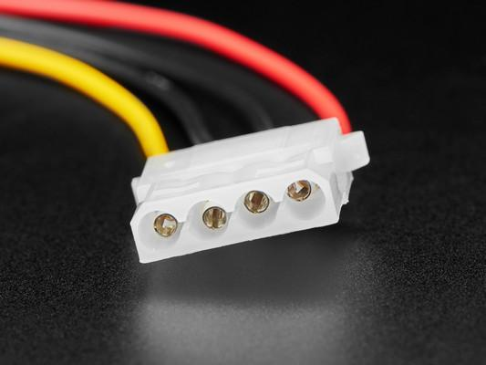

Purpose: Older power connector used for legacy devices.
Devices Powered:
- Older hard drives
- Optical drives
- Case fans
- LED accessories
Safety Tip: Pull the connector by its plastic housing, not by the wires, to avoid damage.
- PCIe 6/8-Pin Power Connector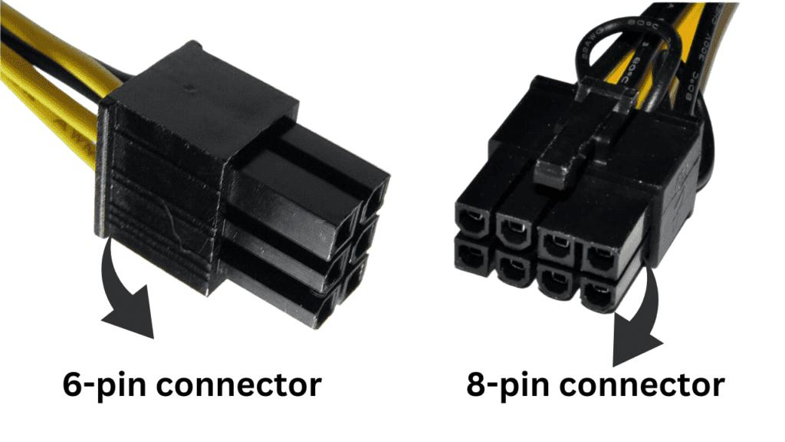
Purpose: Supplies additional power to graphics cards.
Devices Powered:
- Graphics Processing Units (GPUs)
- High-performance expansion cards
Safety Tip: Ensure the connector clicks firmly into place before powering on the system to prevent overheating or instability.

4.)Imagine you are setting up a new gaming PC. List the steps you would follow to connect the SMPS to the motherboard, graphics card, and storage devices, mentioning which specific cables and connectors are used for each.
Steps to Connect the SMPS in a New Gaming PC
Step 1: Install the SMPS
- Mount the SMPS inside the PC case using the provided screws.
- Ensure the fan faces the correct direction for proper airflow.
Step 2: Connect Power to the Motherboard
- Locate the 24-pin ATX power cable from the SMPS.
- Plug the 24-pin ATX connector into the motherboard's main power socket.
- Make sure the connector clicks into place securely.
Step 3: Connect Power to the CPU
- Find the 8-pin EPS/CPU power cable (sometimes 4+4 pin).
- Connect it to the CPU power socket near the processor on the motherboard.
- Verify the locking clip is secured.
Step 4: Connect Power to the Graphics Card (GPU)
- Locate the PCIe 6-pin or 8-pin power cable from the SMPS.
- Connect the required PCIe power connector(s) to the graphics card.
- High-end GPUs may require two or more PCIe connectors.
Step 5: Connect Power to Storage Devices
- Use the SATA power cable from the SMPS.
- Connect the SATA power connector to the SSD, HDD, or optical drive.
- Ensure the L-shaped connector is aligned correctly before inserting.
Step 6: Connect Additional Components
- Connect any case fans, RGB controllers, or accessories using SATA power or Molex connectors, depending on the device requirements.
Step 7: Check All Connections
- Verify that all connectors are fully inserted and locked.
- Ensure no cables are loose or obstructing fans.
Step 8: Power On and Test
- Connect the AC power cable to the SMPS.
- Switch the SMPS power button to ON (I).
- Start the PC and confirm that the motherboard, GPU, and storage devices are detected properly.

THE END……..

